DeepCSAT
E-Commerce Customer Satisfaction Score Prediction
Project Documentation
Prepared by Rohit Sagar Chavan
GitHub repository: https://github.com/mirohit/-E-Commerce-Customer-Satisfaction-Score-Predictor

About this project
Shopzilla is an e-commerce company. Every time a customer contacts support (call, email, or outcall), the customer later gives a CSAT score from 1 to 5 - how happy they were with that interaction. The goal of this project is to build a Deep Learning model (Artificial Neural Network) that can predict this CSAT score directly from the details of the interaction - channel used, category of issue, response time, agent information, customer remarks, and more - so the business does not have to wait for every customer to fill out a survey to know whether service was good or bad.

Phase 1: Exploratory Data Analysis (EDA)

What we did
We took the raw data - 85,907 customer support interactions across 20 columns - and did three things:
- Checked data quality: shape, duplicates, missing values, and datatypes.
- Cleaned and engineered features: parsed dates, calculated response time, and created flags for whether the customer left a remark, whether order info was present, and more.
- Built 15 charts to understand what affects CSAT, plus a correlation heatmap and a pair plot.

Key insights
- CSAT is very imbalanced: 69% of customers gave a score of 5. Very few gave a 2 or 3. This matters a lot, since a model could look accurate just by always guessing 5, while being practically useless.
- Response time matters: the longer it takes to respond to an issue, the lower the CSAT tends to be. One of the clearest, most actionable findings.
- Writing a remark signals dissatisfaction: people mostly write feedback when they are unhappy, so whether a customer wrote anything at all is itself a warning sign.
- Some categories, products, and agent shifts consistently score lower: problems are not spread evenly - they concentrate in specific issue types.
This means CSAT is not the same everywhere. For example, one issue category might average a CSAT of 4.6, another 3.8, and another as low as 3.2. Similarly, a morning shift might show a higher average CSAT than a night shift. This tells the business exactly where customers are having more problems, so those categories, products, or shifts can be investigated directly.
- Data quality is patchy: columns like connected_handling_time (99.7% missing), order_date_time, Customer_City, Product_category, and Item_price (around 80% missing each) were not fake-filled - they were either dropped or their missingness was preserved as a signal (a flag column).
- No single feature alone predicts CSAT: this is the most important point for understanding why an ANN was chosen. Individual features overlap heavily across CSAT groups - a 5-minute response time could still lead to a CSAT of 2, 3, 4, or 5, and the same is true for issue category, agent, or channel alone. But combining many features together can produce a meaningfully better prediction.
Channel + Issue category + Response time + Agent + Remark information + Other features -> ANN -> Predicted CSAT
That is where a neural network becomes useful: it can learn combinations and interactions between many signals at once, rather than relying on any single simple rule. Summary: the data is clean, the target is imbalanced, response time and remarks are the strongest early signals, and no single feature is enough on its own - so an ANN combining everything makes sense.

Phase 2: ML / ANN Modeling

What we did
- Started from the cleaned EDA data (85,907 interactions) and added extra engineered features: response time in minutes, remarks length, and presence flags for order info and item price.
- Ran 3 hypothesis tests to statistically confirm what the EDA suggested, rather than trusting a visual impression: response time affects CSAT (confirmed), whether the customer wrote a remark affects CSAT (confirmed), and support channel affects CSAT (confirmed).
- Prepared the data for the neural network: filled missing values sensibly using medians (not random guesses), capped extreme outliers (such as a clearly erroneous item price), converted categorical columns into numbers, built a full text-processing pipeline for Customer Remarks (cleaning, root-word reduction, then TF-IDF + SVD), and scaled all numeric features to the same range.
- Handled the class imbalance: since 69% of customers rated 5/5, class weighting was used so the model pays real attention to the rare cases (1, 2, 3) instead of ignoring them.
- Built and honestly compared 3 ANN architectures - see the table below.
Model | Simple difference
Model 1 | Basic ANN - 2 hidden layers, no Dropout or Batch Normalization. Input -> 64 -> 32 -> Output. This is the model that was ultimately selected as the winner after tuning.
Model 2 | More complex ANN - deeper/wider network plus Batch Normalization and Dropout. Input -> 128 -> 64 -> 32 -> Output, with BatchNorm + Dropout after the first two hidden layers. Batch Normalization keeps values flowing through the network in a stable range so training is faster and smoother. Dropout randomly switches off a percentage of neurons during training (e.g. 30% of 100 neurons) so the model doesn't over-rely on specific neurons, reducing overfitting.
Model 3 | Tuned/final ANN - moderate architecture plus BatchNorm, Dropout, learning-rate adjustment, and EarlyStopping. Input -> 128 -> 64 -> Output, with BatchNorm + Dropout. ReduceLROnPlateau automatically shrinks the learning rate when the model stops improving. EarlyStopping watches validation performance and stops training if it stalls for several rounds, avoiding wasted time and overfitting.
Table 1: The three ANN architectures compared in this project
- Picked the winner based on real, measured performance rather than assumption. Macro F1 (fair to every class, not just the majority one) was used as the deciding metric, and the simplest model - Model 1, tuned - actually won, outperforming the deeper, more complex architectures.
- Saved the winning model together with everything needed to reuse it later - this is exactly what powers the Streamlit deployment app.

Insights found
- CSAT is genuinely difficult to predict: macro F1 is only around 0.25 to 0.26. The model predicts CSAT 1 and CSAT 5 noticeably better than the middle scores, 2 and 3.
- The simpler model performed better: the more complex ANN architectures (Model 2 and Model 3) did not improve performance - the simplest model was the winner. This is reported honestly rather than defaulting to the most complex option.
- Response time and customer remarks are important: slower response times and the presence of a customer remark are both linked with lower CSAT scores.
- Limited sentiment understanding: the model does not truly understand the customer's tone. It relies more on structured features like category and response time than on the actual meaning of the customer's written text.

Local deployment: app.py
app.py is the Streamlit web app - it takes everything built in the ML notebook and turns it into something usable through a browser, with no code required from the user.
- Built a form to enter the details of a customer support interaction: channel, category, sub-category, agent tenure, shift, day, response time, item price, city, product category, and the customer's written remark.
- Loads the trained model and all its preprocessing pieces (scaler, TF-IDF, SVD, etc.) once when the app starts, so nothing reloads on every click.
- Connects the form to csat_inference.py - when "Predict CSAT Score" is clicked, whatever was typed is run through the exact same cleaning and encoding steps used during training, then fed to the ANN.
- Displays the result clearly: the predicted CSAT score (1-5), a colored warning for low scores ("recommend supervisor review"), and a bar chart showing the model's confidence across all 5 possible scores.
- Includes an "About this model" tab explaining honestly what the model does well and where it struggles.

Running the app
cd "C:\Users\Rohit Sagar Chavan\Music\ML Engineering\DeepCSAT E-Commerce Customer Satisfaction Score Prediction (EDA)\deepcsat_streamlit_app"
python -m streamlit run app.py

App in action
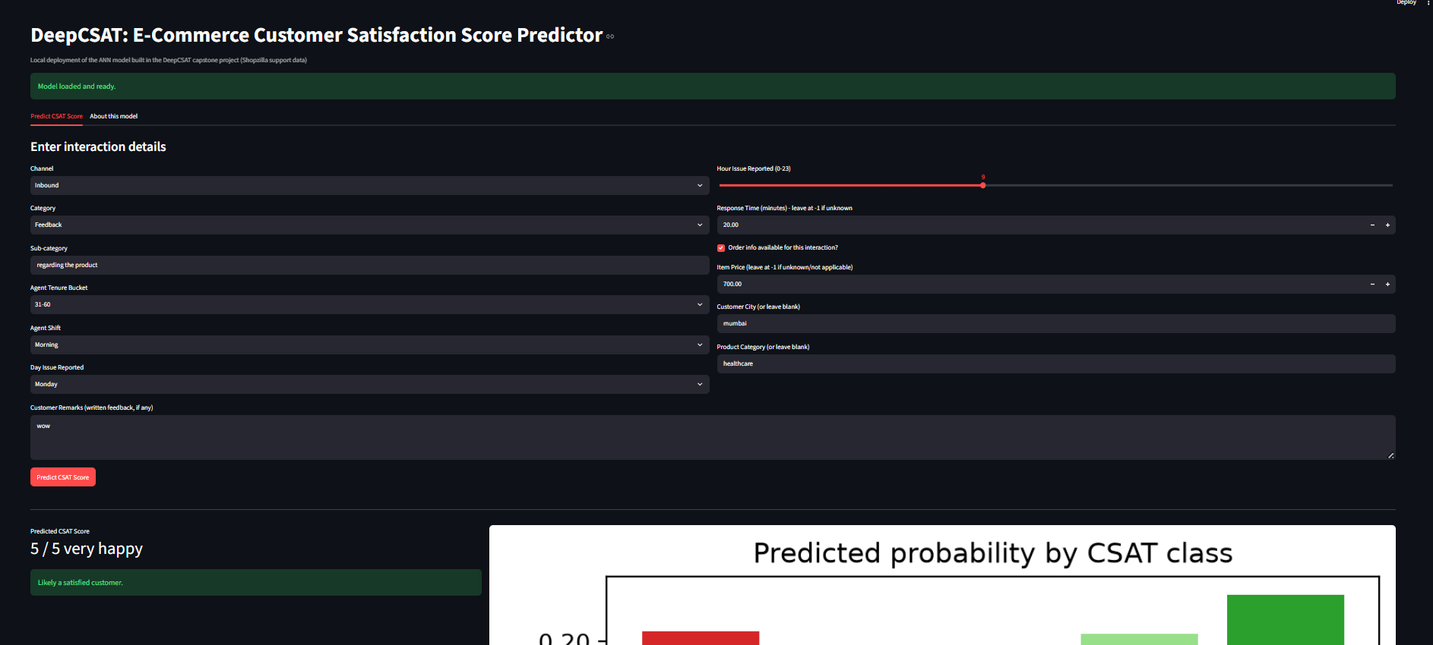
Figure 1: The DeepCSAT Streamlit app predicting a CSAT score of 5/5 (very happy) from a fast response, a positive short remark ("wow"), and a low-friction interaction (Feedback category, Inbound channel, 20-minute response time).

Deployment pipeline: build_deployment_artifacts.py
build_deployment_artifacts.py is the script that trains the ANN model from scratch and packages everything the app needs to make predictions - it is the bridge between the ML notebook and the Streamlit app. The ML notebook is the lab where three models were experimented with and compared; this script takes the winning recipe, retrains it fresh, and packs it into a box (the saved_model folder) that the app can grab and use directly.

What it builds, step by step
- 1. Loads and cleans the raw data: reads eCommerce_Customer_support_data.csv and applies the exact same cleaning as the EDA/ML notebooks - parses dates, calculates response time, creates flags for missing data, and drops the unusable column.
- 2. Prepares the data, and saves the recipe: fills missing values with medians, caps extreme outliers, and encodes categories (one-hot for common ones, frequency encoding for rare ones like Sub-category). Crucially, it saves the exact medians and bounds used, so any new prediction later is treated exactly the same way the training data was.
- 3. Processes the customer remarks text: runs the full text-cleaning pipeline on Customer Remarks (lowercase, remove punctuation, remove stopwords, lemmatize), then converts it to numbers using TF-IDF and SVD - and saves those trained tools so new remarks are converted the same way.
- 4. Trains the ANN model: trains the winning architecture from the ML notebook (Model 1 Tuned: 2 hidden layers, 64 to 32 units) on this data, using class weighting to handle the imbalance, with early stopping so it does not overtrain.
- 5. Evaluates honestly: prints Accuracy and Macro F1 on held-out test data honestly, not hidden, so the model can be trusted before being deployed (macro F1 was approximately 0.255 when this was run).
- 6. Saves everything needed for the app: saves the trained model and every preprocessing tool (scaler, TF-IDF, SVD, medians, outlier bounds, frequency maps, category lists) into the saved_model folder - this is exactly what app.py loads every time it launches.

Why this file matters specifically
The model, scaler, and TF-IDF files originally saved by the ML notebook were not actually complete enough to score a brand-new, single customer interaction - they were missing the medians, outlier bounds, and frequency maps mentioned above. This script closes that gap by saving the complete set of tools needed, which is exactly why app.py's predictions work correctly today.

Prediction engine: csat_inference.py
csat_inference.py is the prediction engine - the code that actually takes one customer interaction (whatever is typed into the app) and turns it into a CSAT score. It is not used for training - that is what build_deployment_artifacts.py is for. This module exists purely to use the already-trained model. In simple terms: build_deployment_artifacts.py builds the calculator, csat_inference.py is the calculator, and app.py is just the buttons and screen used to operate it.

What it builds, step by step
- 1. load_artifacts(): opens the saved_model folder and loads the trained ANN model plus every preprocessing tool - scaler, TF-IDF vectorizer, SVD transformer, medians, outlier bounds, frequency maps, and category lists. This only needs to happen once, when the app starts.
- 2. load_nltk_tools(): prepares the stopword list and the lemmatizer needed to clean text, downloading NLTK resources if they are not already present.
- 3. clean_text_pipeline(): runs a single customer remark through the exact same cleaning steps used in training - expand contractions, lowercase, remove punctuation/URLs/numbers, remove stopwords, tokenize, lemmatize. This has to be identical to training, or predictions would be wrong.
- 4. build_feature_row(): the most important function - takes raw form inputs (channel, category, response time, remark text, and so on) and turns them into the exact same 94-number row format the model was trained on, filling missing values with the saved medians, capping outliers with the saved bounds, one-hot/frequency encoding categories, running the text through TF-IDF and SVD, and scaling everything with the saved scaler.
- 5. predict_csat(): ties it all together - calls build_feature_row(), feeds the result to the model, and returns the predicted score (1 to 5) plus the full probability breakdown across all 5 classes. This is the function app.py calls whenever the Predict button is clicked.

This documentation covers the DeepCSAT capstone project end-to-end: exploratory data analysis, ANN model development and honest comparison, and local deployment via Streamlit. The full project, including both notebooks and the deployment app, is available at the GitHub repository linked on the title page.

